## horizontal line



UNVEILING MARKET INSIGHTS:

**Analyzing Spending Behaviour And Identifying**

## 

## 

## Team One

Third BSc Physics[ EM]

Presidency College

Chennai -05

# 

# 1. INTRODUCTION

**1.1 OVERVIEW**

Wholesaling or distributing is the sale of goods to retailers to industrial, commercial, institutional or other professional businessmen to other wholesalers (wholesale businesses) and related subordinated services. Wholesaling is buying goods in bulk quantity, usually directly from the manufacturer or source, at a discounted rate. The retailer then sells the goods to the end consumer at a higher price making a profit.

The consumption and production of marketed food are spatially separated. Production is primarily in rural areas while consumption is mainly in urban areas. In today's highly competitive business landscape, gaining deep market insights is essential for businesses to thrive and grow. This project aims to analyse customer spending behaviours and identify opportunities for growth by leveraging data analytics and data-driven decision-making.

The primary objective of this project is to understand customer spending patterns, preferences, and trends across various dimensions. By conducting a comprehensive analysis, businesses can optimise their marketing strategies, improve product offerings, and enhance customer engagement to drive revenue growth.

**1.2 PURPOSE**

There are a lot of purpose on learning and applying "Unveiling Market Insights: Analysing Spending Behaviours and Identifying Opportunities for Growth":

**1. Product Development:** By analysing spending behaviours, businesses can identify gaps in the market and develop new products or services that cater to unmet consumer needs.

**2. Marketing Strategy:** Tailoring marketing campaigns to specific consumer segments based on spending behaviours and preferences can significantly improve campaign effectiveness.

**3.Customer Experience Enhancement:** Identifying pain points and preferences through spending analysis can lead to improvements in the customer experience, increasing customer satisfaction and loyalty.

**4. Market Expansion:** Discovering growth opportunities in new geographic regions or demographic segments can guide expansion strategies.

**5. Competitive Analysis:** Analysing consumer spending can shed light on what competitors are doing right or wrong, aiding in competitive strategy development.

**6. Investment Decisions:** Investors can use market insights to make informed investment decisions, choosing companies positioned for growth.

**8. Risk Mitigation:** Recognizing economic or industry-specific trends can help businesses anticipate and mitigate potential risks.

Learning and applying these insights is vital for businesses aiming not only to survive but to thrive in an ever-evolving market landscape.

# 2. PROBLEM DEFINITION AND DESIGN THINKING

2.1 Empathy Map

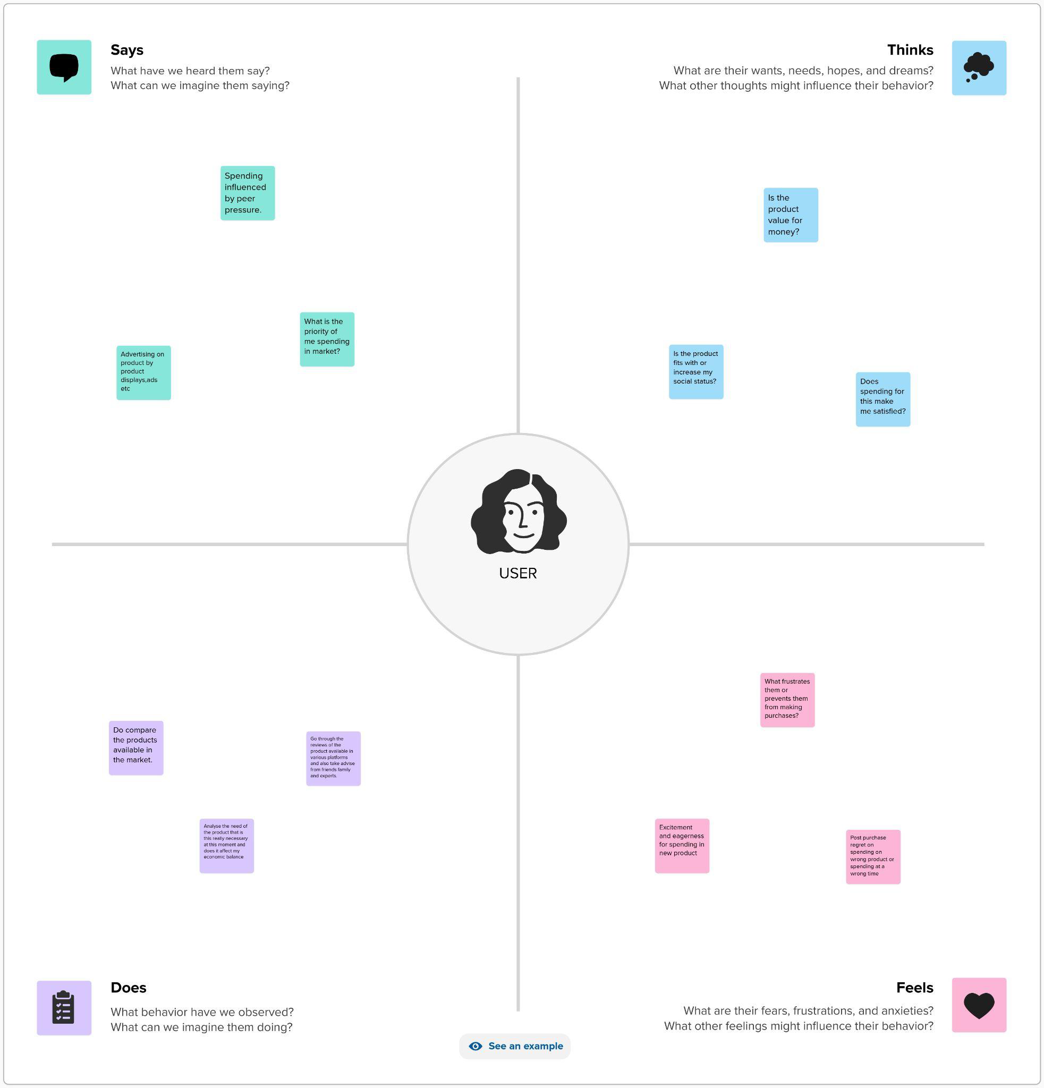

2.2 IDEATION AND BRAINSTORMING MAP

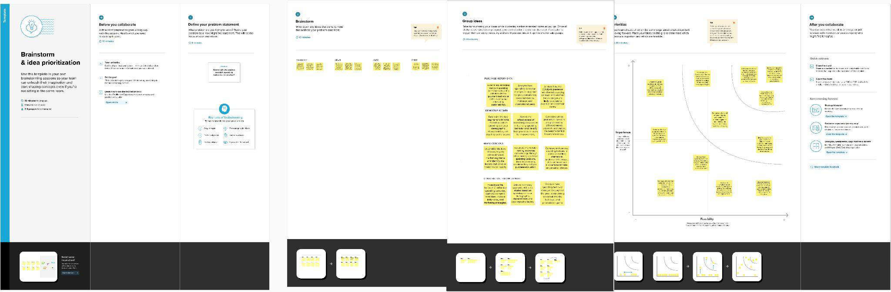

# 

# 3. RESULT

3.1 DASHBOARD

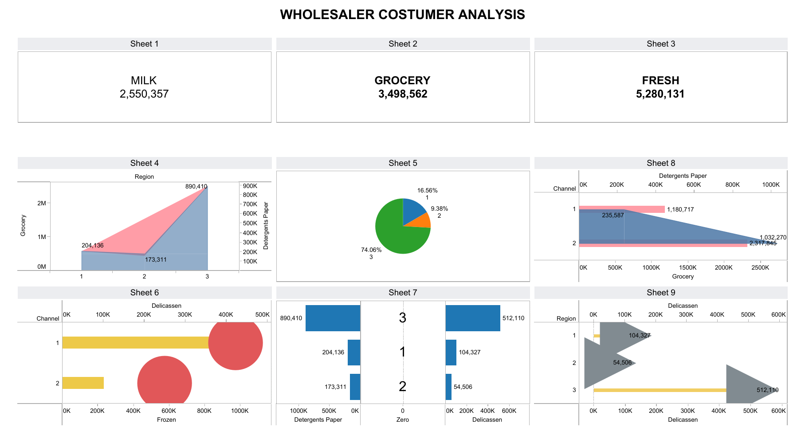

3.2 STORY

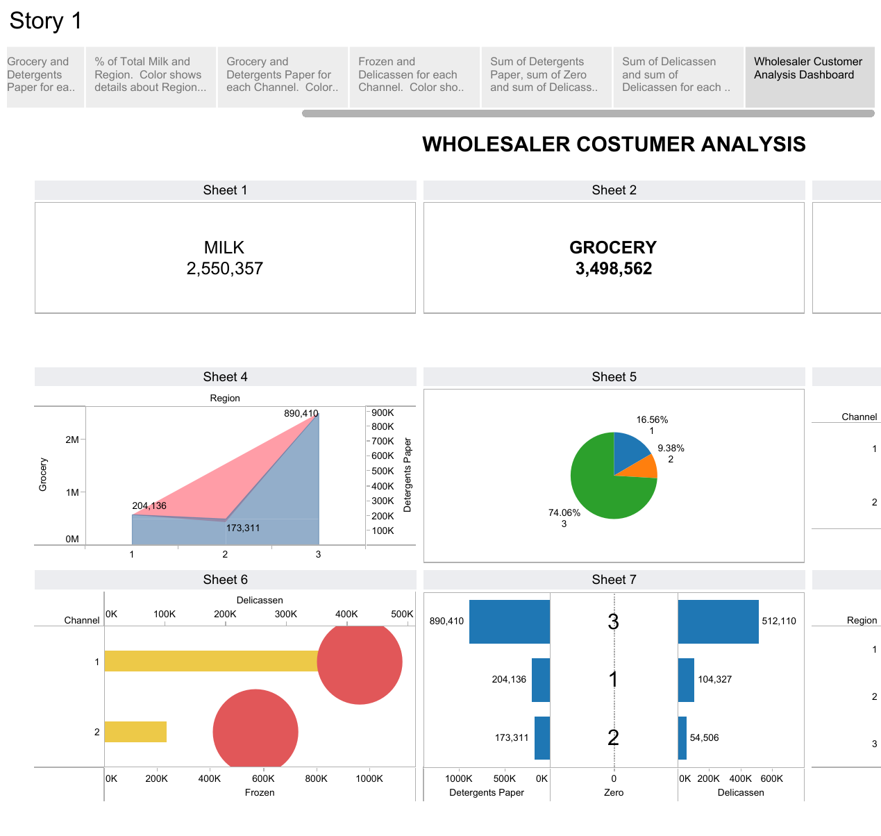

# 4 ADVANTAGES AND DISADVANTAGES

4.1 ADVANTAGES

The project "Unveiling Market Insights: Analysing Spending behaviours and Identifying Opportunities for Growth" offers several distinct advantages for businesses:

**1. Informed Decision-Making:** It provides data-driven insights that empower businesses to make informed decisions across various aspects of their operations, reducing reliance on guesswork.

**2. Competitive Advantage:** Understanding consumer spending behaviours allows companies to gain a competitive edge by tailoring their products, services, and marketing strategies to better align with consumer preferences.

**3. Risk Mitigation:** Awareness of market trends and consumer behaviours enables businesses to anticipate and mitigate risks associated with economic fluctuations or changes in consumer preferences.

**4. Improved Customer Engagement:** Tailored marketing campaigns and personalized experiences based on spending insights can lead to higher customer engagement, loyalty, and satisfaction.

**5. Enhanced Product Development:** It guides the development of products or services that meet consumer needs, reducing the risk of launching offerings that don't resonate with the market.

**6. Increased Profitability:** Optimized pricing strategies based on consumer willingness to pay can lead to increased profitability while maintaining competitiveness.

**7. Environmental Responsibility:** Understanding consumer interest in eco-friendly products can guide sustainability efforts and eco-conscious marketing, promoting corporate responsibility.

**8. Customer Retention:** A better understanding of consumer preferences allows for improved customer retention strategies, reducing churn and increasing customer lifetime value.

**9. Enhanced Supply Chain Management:** Insights into consumer demand patterns can lead to more efficient supply chain management, reducing costs and improving delivery times.

**10. Investor Attraction:** Companies armed with strong market insights can attract investors looking for evidence of well-informed and growth-oriented strategies, potentially leading to increased funding.

In summary, the project's advantages extend to all facets of a business, from strategic decision-making to operational efficiency and customer-centricity. It equips companies with the tools needed to thrive in a competitive and ever-changing marketplace.

4.2 DISADVANTAGES

While "Unveiling Market Insights: Analysing Spending behaviours and Identifying Opportunities for Growth" offers numerous benefits, it also comes with some potential disadvantages and challenges:

**1. Data Privacy Concerns:** Collecting and analysing consumer data can raise privacy concerns. Ensuring compliance with data protection regulations like GDPR and maintaining the security of sensitive information is paramount.

**2. Data Accuracy and Quality:** The quality of insights depends on the accuracy and completeness of the data collected. Inaccurate or incomplete data can lead to misguided decisions.

**3. Data Overload:** Handling large volumes of data can be overwhelming. Without effective data management and analysis tools, businesses may struggle to derive meaningful insights.

**4. Costs:** Implementing data analytics and research processes can be costly, especially for small businesses with limited budgets.

**5. Technical Expertise:** Effective data analysis requires skilled professionals who understand statistical methods, data analytics tools, and software. Hiring or training such personnel can be a challenge.

**6. Time-Consuming:** Collecting, processing, and analysing data is a time-consuming process. Businesses may not see immediate results, and patience is required.

**7. Consumer Trust:** If consumers perceive that their data is being exploited, it can damage trust and brand reputation. Maintaining transparency about data usage is essential.

**8. Competitive Espionage:** Businesses must protect their data and insights from competitors who may seek to gain an advantage.

**9. Technology Dependency:** Relying heavily on technology for data collection and analysis makes businesses vulnerable to technological failures and disruptions.

**10. Bias in Data:** Biases can exist in data collection methods or in the data itself, leading to skewed insights and decisions.

Despite these disadvantages and challenges, many businesses find that the benefits of unveiling market insights outweigh the drawbacks. Effective planning, data governance, and ethical considerations can help mitigate these issues and make the project a valuable asset for growth and decision-making.

# 

# 

# 5 APPLICATIONS

The project "Unveiling Market Insights: Analysing Spending Behaviours and Identifying Opportunities for Growth" is a versatile tool that can benefit various areas within a business. Here are some key areas where it helps:

**1. Product Development:** It aids in identifying market gaps and consumer preferences, guiding the development of new products or improvements to existing ones.

**2. Marketing Strategy:** Spending behaviours insights inform targeted marketing campaigns and messaging, optimizing the allocation of marketing budgets.

**3. Pricing Strategies:** Businesses can set optimal pricing strategies based on consumer willingness to pay, maximizing profitability while remaining competitive.

**4. Customer Experience:** Understanding consumer preferences helps enhance the customer journey, leading to improved customer satisfaction and loyalty.

**5. Market Expansion:** The project identifies growth opportunities in new demographics or geographic regions, facilitating strategic expansion plans.

**6. Risk Mitigation**: Awareness of market trends and consumer behaviours aids in mitigating risks associated with economic fluctuations or changes in consumer preferences.

**7. Competitive Analysis:** It helps in understanding what competitors are doing right or wrong, informing competitive strategy development.

**8. Sustainability Initiatives:** Companies can align with consumer preferences for sustainable products, promoting corporate responsibility.

**9. Supply Chain Optimization:** Understanding consumer demand patterns assists in streamlining supply chains for efficiency.

**10. New Market Entry:** It helps businesses assess the feasibility of entering new markets, minimizing risks associated with unfamiliar consumer behaviours.

In essence, the project's utility extends across the entire spectrum of business operations, enabling companies to make informed decisions, adapt to changing market conditions, and seize opportunities for growth in a highly competitive environment.

# 6. CONCLUSION

In conclusion, the project "Unveiling Market Insights: Analysing Spending Behaviours and Identifying Opportunities for Growth" emerges as a pivotal strategy in today's dynamic business landscape. By delving deep into consumer spending habits, collecting and analysing data, and staying attuned to market trends, businesses gain a powerful tool for sustainable growth.

Through this approach, companies can refine their product development, marketing, and pricing strategies to align seamlessly with consumer preferences. It empowers businesses to make informed, data-driven decisions, ensuring that resources are allocated efficiently and risks are mitigated effectively.

Furthermore, the project opens doors to innovation and market expansion. By identifying unmet needs and emerging trends, companies can position themselves strategically to seize growth opportunities and gain a competitive edge.

# 

# 7. FUTURE SCOPES

The future scope of the project "Unveiling Market Insights: Analysing Spending Behaviours and Identifying Opportunities for Growth" holds immense potential as businesses continue to adapt to evolving consumer preferences and technological advancements. Here are some key aspects of its future scope:

**1. Advanced Data Analytics:** As data analytics tools and techniques continue to advance, the project's scope will expand. Predictive analytics and machine learning algorithms can provide more accurate insights into future consumer behaviour and market trends.

**2. Personalization:** The future will see an increased focus on hyper-personalization. Businesses will use spending behaviour insights to tailor products, services, and marketing messages to individual consumers, enhancing customer experiences.

**3. Ethical Consumerism:** With growing concerns about sustainability and ethical consumption, the project can delve into consumer spending related to ethical and sustainable products, offering insights into how businesses can align with these values.

**4. Artificial Intelligence (AI) Chatbots:** AI-driven chatbots can interact with consumers to gather real-time spending behaviour data, offering immediate insights for businesses.

**5. Health and Wellness:** Understanding consumer spending on health and wellness products and services can be particularly relevant in a post-pandemic world, where health-consciousness is on the rise.

In essence, the future scope of this project is boundless, as it continues to adapt to the ever-changing landscape of consumer behaviour, technological innovations, and global market dynamics. It will remain an indispensable tool for businesses striving for growth and competitiveness.